Homework – 6

1. Consider the pushdown automata $M=(K,Σ,Γ,Δ,s, F)$, where

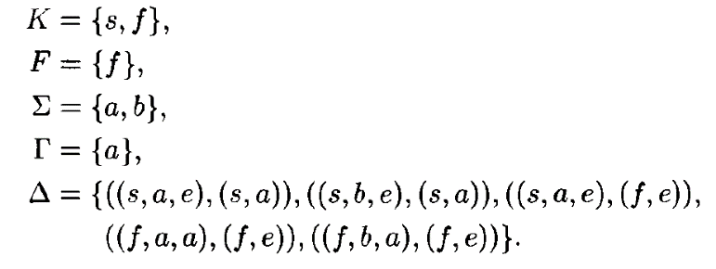

a). Trace all possible sequence of transitions of $M$ on input $aba$

b). Show that $aba,aa,abb∉L\left(M\right)$, but $baa,bab,baaaa∈L(M)$

c). Describe $L(M)$ in English

1. Construct a Pushdown automata that accept each of the followings:

a). The language $\{w∈{\left\{a,b\right\}}^{*}:w=w^{R}\}$

b). The language $\{w∈{\left\{a,b\right\}}^{*}:w has the same number of a^{'}s and b's\}$